* **Data warehousing** is the process of storing the data from various sources together such that the data is meaningful and it can be easily retrieved.
* A data warehouse stores historical data and data is gathered from multiple sources
* OLTP/ Database: Mostly stores only current transactional data
* **OLAP**- Online Analytical processing: When we are querying data from data warehouse for analytical processing; it can be called as OLAP
* A DWH consist of raw data, Aggregate data and metadata. Medata is the information about what is stored in the DWH. i.e. what are the tables stored and what are attributes stored in DWH.

* **Data Marts**- Subset of DWH. they store data about a specific domain. The DWH is separated into data marts if we don't want to give access to each user for whole DWH. The specific users will be given access to specific data marts.

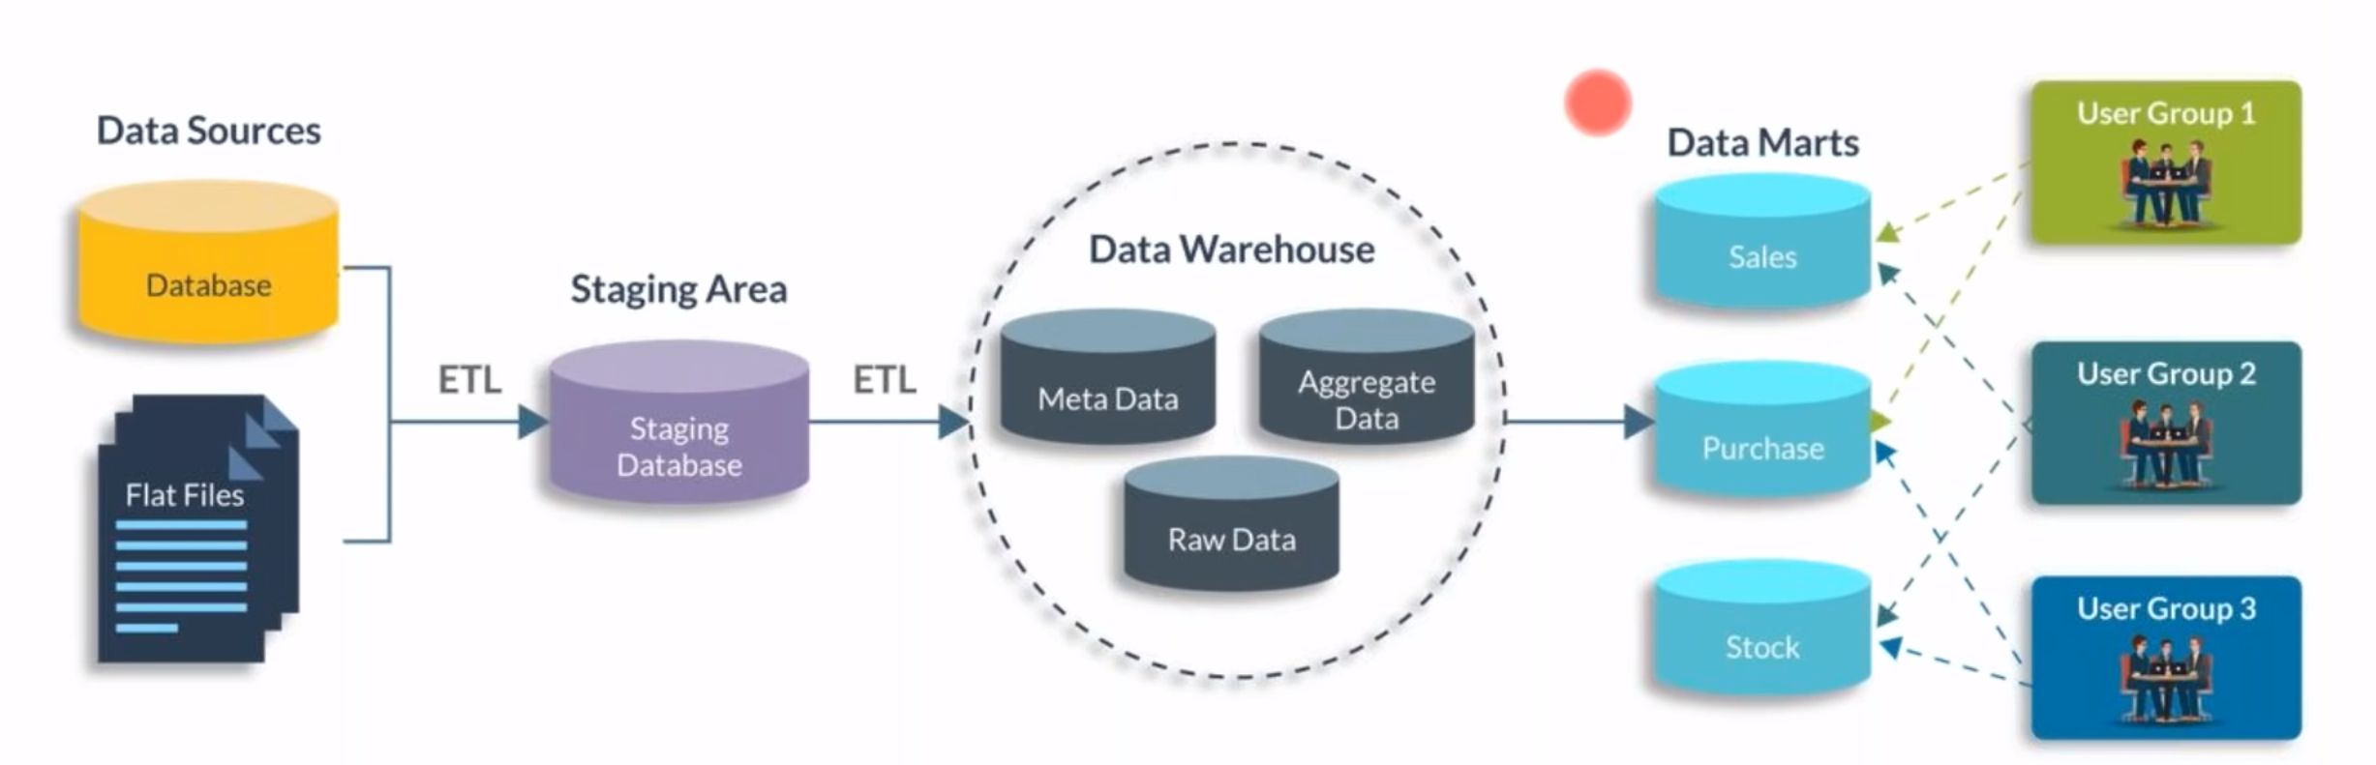

* OLTP data is stored in relational database in 2 dimensional structure.
* OLAP is way to analyze complicated multidimensional data.
* DWH is modelled on concept of OLAP while DB is modelled on concept of OLTP.
* **Types of OLAP cubes:**
* **MOLAP:** is a form of OLAP that processes and stores data in multidimensional database.

Adv. Excellent performance, can perform complex calculations

DisAdv: Handles limited data

* **ROLAP:** is a form of OLAP which performs dynamic multidimensional analysis of data stored in relational database.

Adv. More amount of data can be processed

DisAdv. Occupy more disk space and queries are time consuming.

* **HOLAP:** is combination of MOLAP and ROLAP

Adv. HOLAP can drill through from cube to underlying relational data.

**Type of OLAP Operations:**

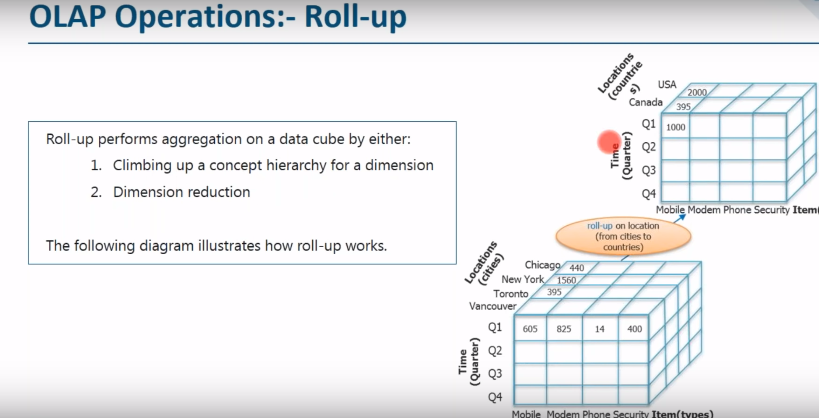

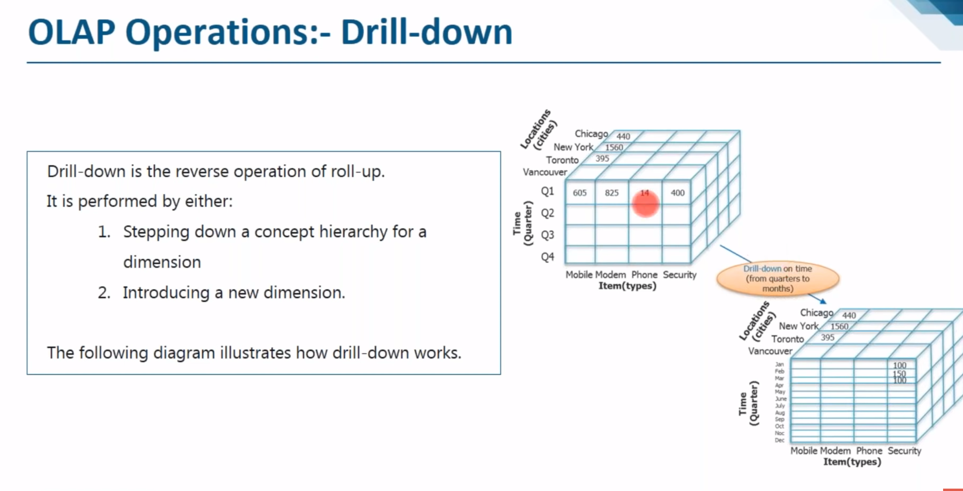

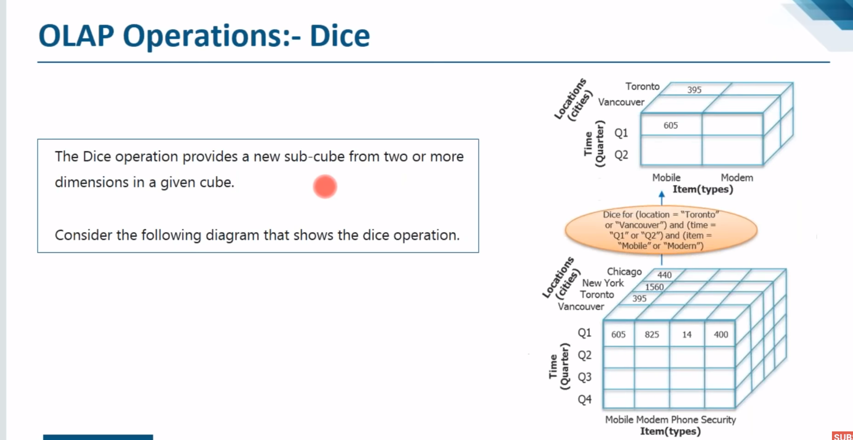

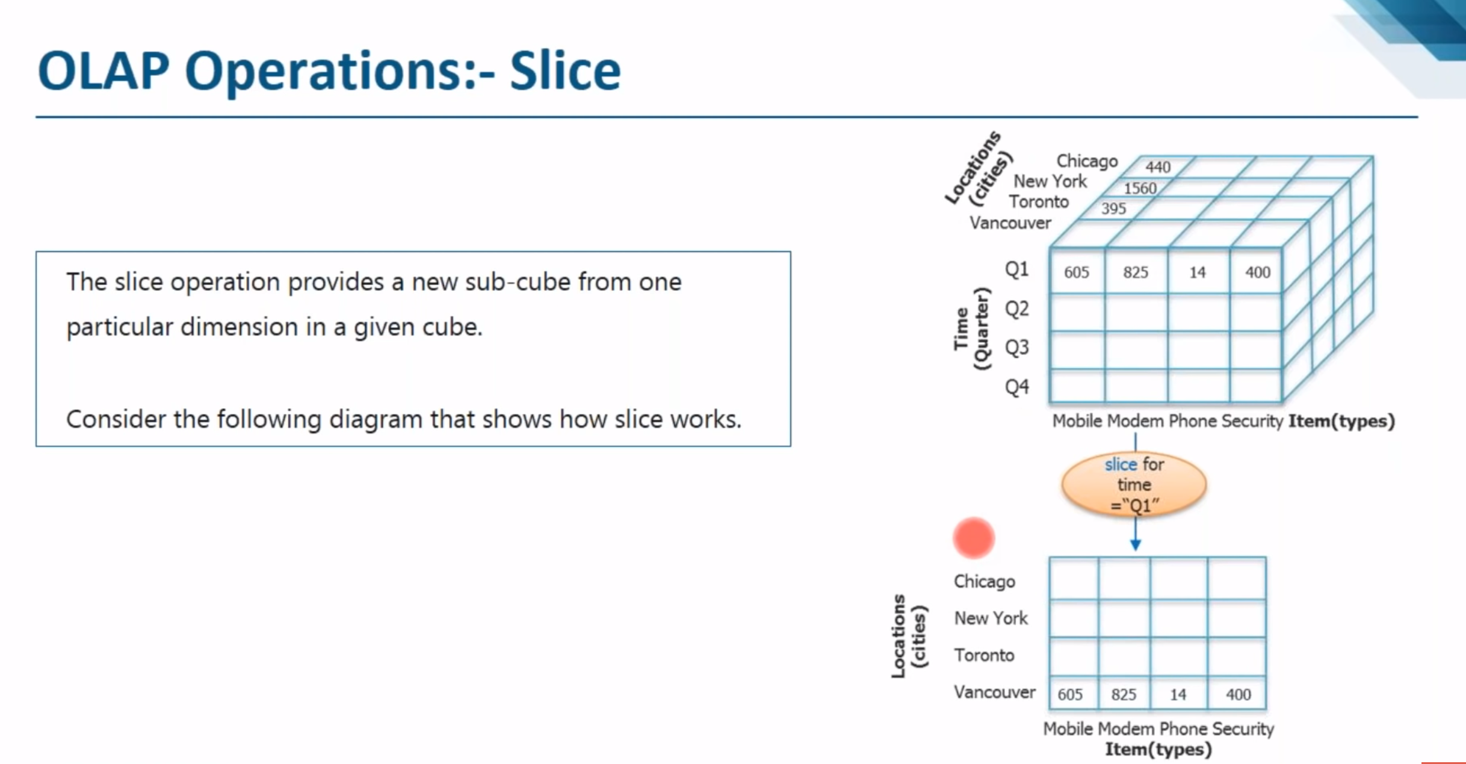

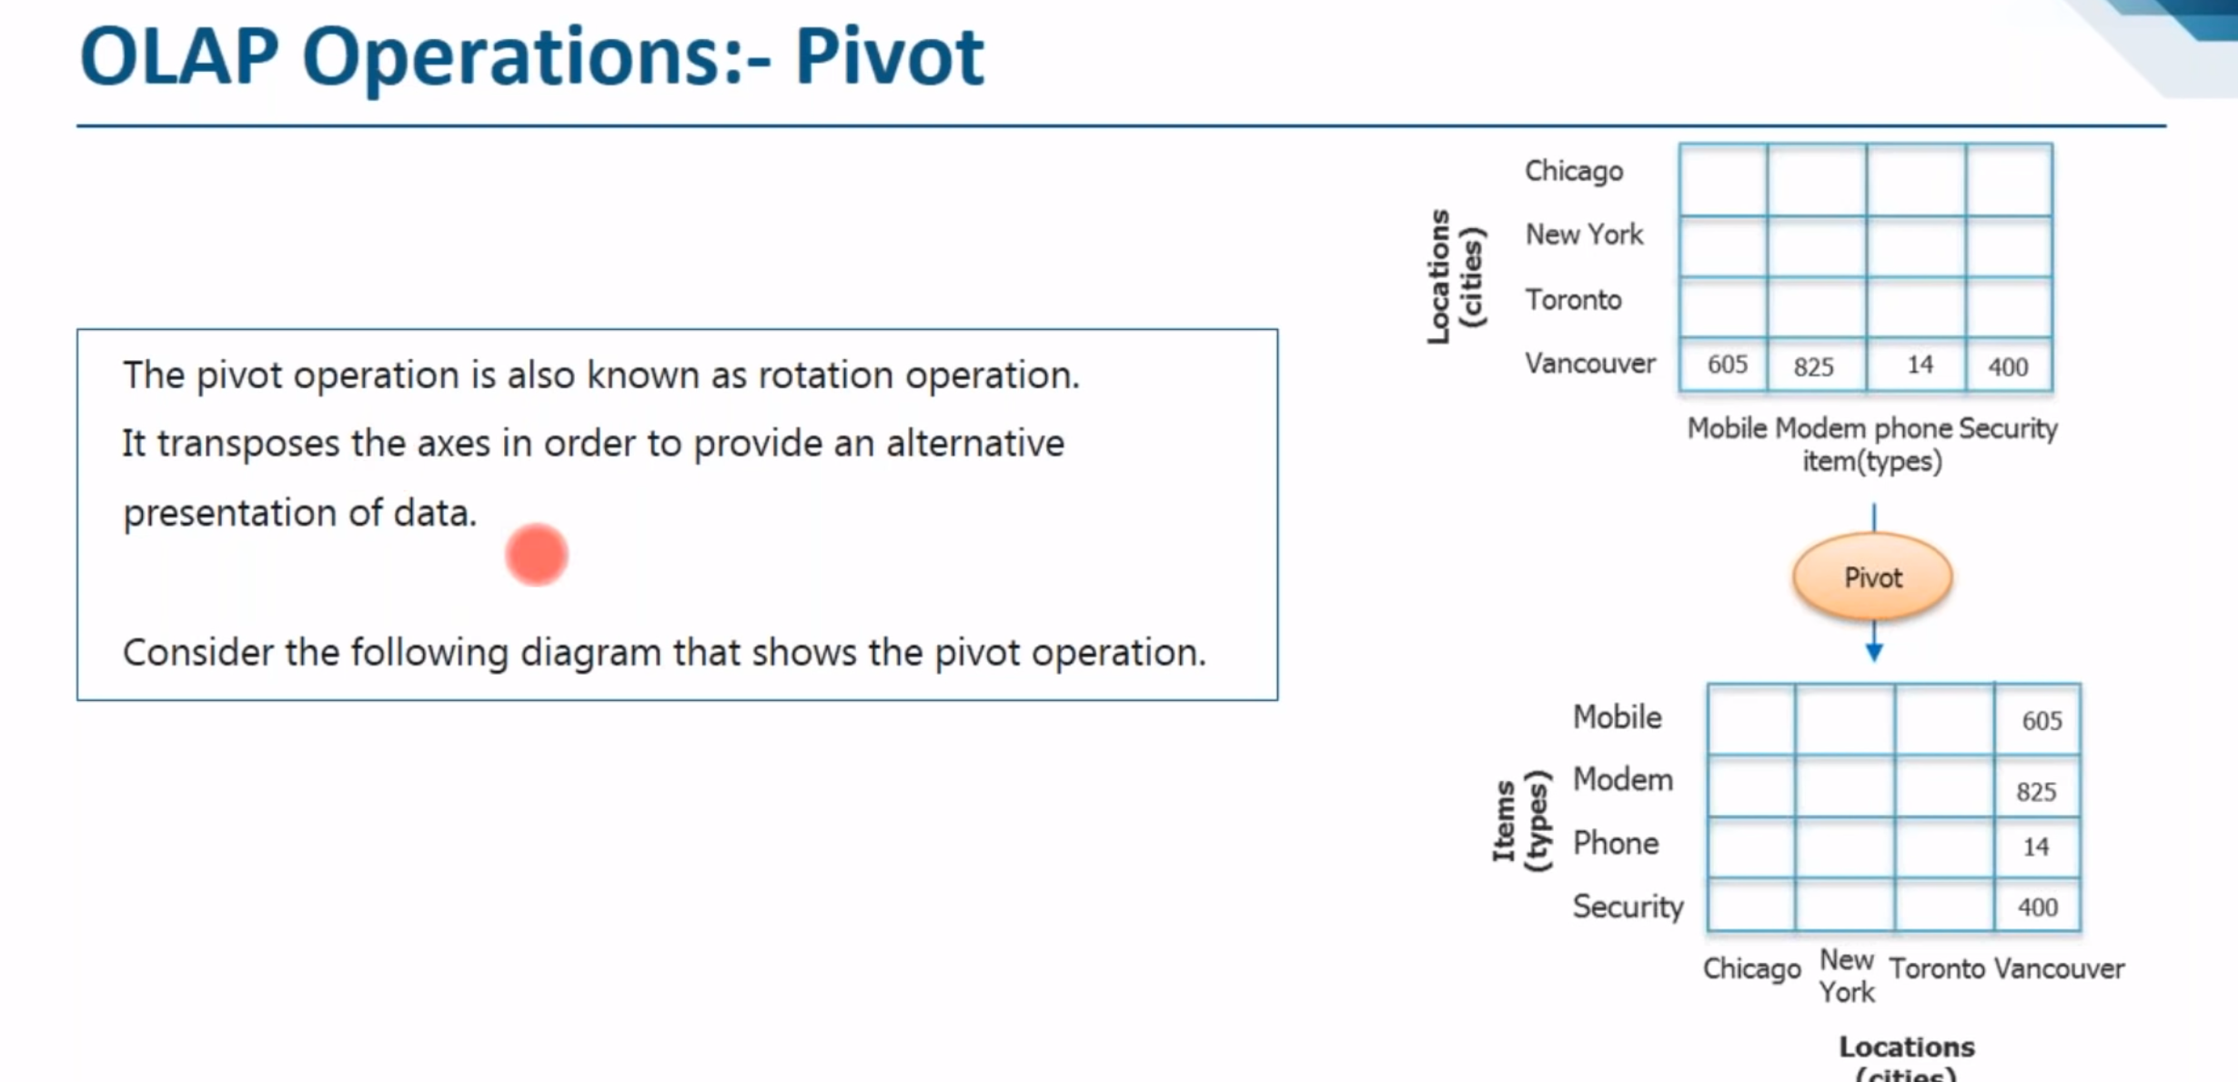

**Dimensional Tables:** Tables that store information about the dimensions. Dimensions are descriptive information about an object.

Dividing DWH into dimensions provides structured information for analysis and reporting.

Facts: Are the measures that can be aggregated or manipulated. Fact is quantitative measurement data for an object.

The fact tables contains measures and dimension key (which connects fact table with the dimension table).

**Type of Schemas in DWH:**



